**Graduation Project**

**T1 {P=5, E=2.3, D=5}, T2 {P=20, E=3, D=20}**

**CPU Utilization = (2.3/5) + (3/20) = 0.61 = 61%**

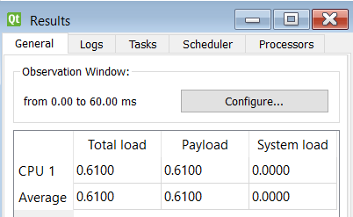

**/***********************************************/**

**Time Demand Analysis: -**

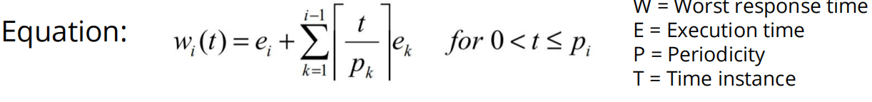

**Task 1:**

**W (1) = 2.3 + 0 = 2.3**

**-**

**-**

**-**

**-**

**W (5) = 2.3 + 0 = 2.3**

**W (5) < Deadline => So Task1 is Schedulable.**

**Task 2:**

**W (1) = 3 + (1/5) * 2.3 = 6.3**

**W (2) = 3 + (2/5) * 2.3 = 6.3**

**W (3) = 3 + (3/5) * 2.3 = 6.3**

**W (4) = 3 + (4/5) * 2.3 = 6.3**

**W (5) = 3 + (5/5) * 2.3 = 6.3**

**W (6) = 3 + (6/5) * 2.3 = 7.6**

**W (7) = 3 + (7/5) * 2.3 = 7.6**

**W (8) = 3 + (8/5) * 2.3 = 7.6**

**W (9) = 3 + (9/5) * 2.3 = 7.6**

**W (10) = 3 + (10/5) * 2.3 = 7.6**

**W (11) = 3 + (11/5) * 2.3 = 9.9**

**W (12) = 3 + (12/5) * 2.3 = 9.9**

**W (13) = 3 + (13/5) * 2.3 = 9.9**

**W (14) = 3 + (14/5) * 2.3 = 9.9**

**W (15) = 3 + (15/5) * 2.3 = 9.9**

**W (16) = 3 + (16/5) * 2.3 = 12.2**

**W (17) = 3 + (17/5) * 2.3 = 12.2**

**W (18) = 3 + (18/5) * 2.3 = 12.2**

**W (19) = 3 + (19/5) * 2.3 = 12.2**

**W (20) = 3 + (20/5) * 2.3 = 12.2**

**W (20) < Deadline => So Task2 is Schedulable.**

**SIMSO**

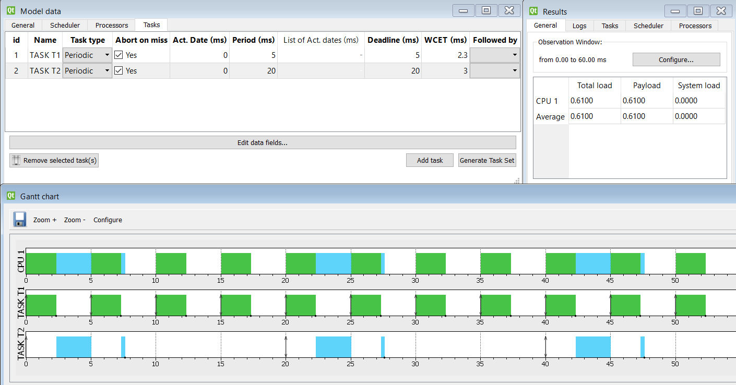

**Logic Analyzer**

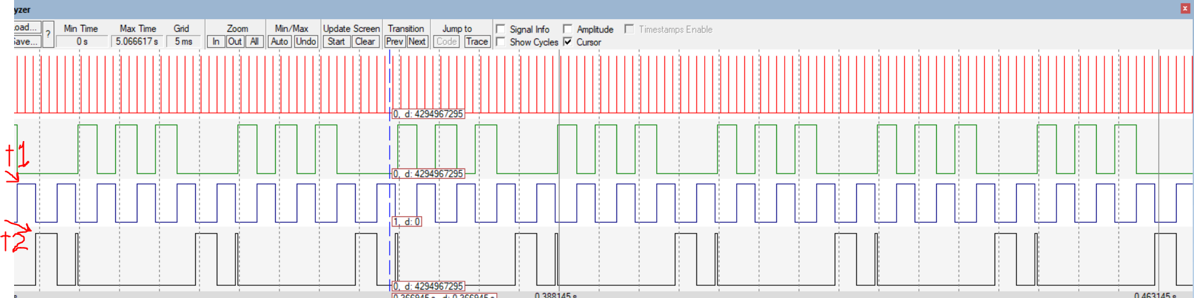

**Notes**

**- Task 2 is pre-empted by task 1 in our EDF scheduler, because Task1 have an earlier deadline(5<20) so it has a higher priority to run.**

**- The new Scheduler uses only periodic tasks, No aperiodic tasks.**